
NARROGIN SHS

SEMESTER ONE EXAMINATION 2002

HISTORY DOCUMENT BOOKLET

CONTENTS

Document Set 1 The Great Depression, Franklin Delano Roosevelt and The New Deal

Document Set 1: United States of America 1917-1941

Source 1

… The country needs and, unless I mistake its temper, the country demands bold, persistent experimentation. It is common sense to take a method and try it: If it fails, admit it frankly and try another. But above all, try something. The millions who are in want will not stand by silently forever while the things to satisfy their needs are within easy reach.

We need enthusiasm, imagination and the ability to face facts, even unpleasant ones, bravely. We need to correct, by drastic means if necessary, the faults in our economic system from which we now suffer. We need the courage of the young. Yours is not the task of making your way in the world, but the task of remaking the world which you will find before you. May every one of us be granted the courage, the faith and the vision to give the best that is in us to that remaking! …

Extract from Address by Roosevelt to students at Oglethorpe University, May 22, 1932

Source 2

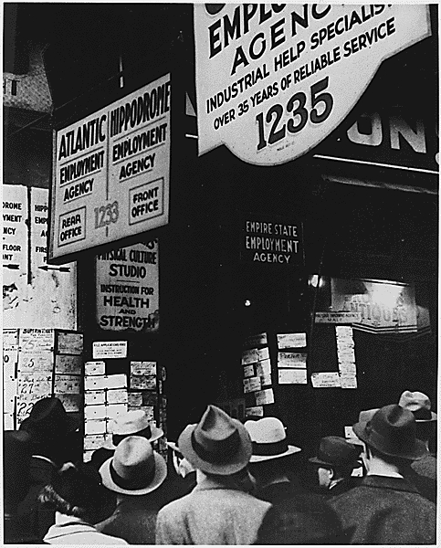
A

Depression:Unemployed: Typical picture capturing the number of people
who were unemployed and looking for a job. (Circa 1935)

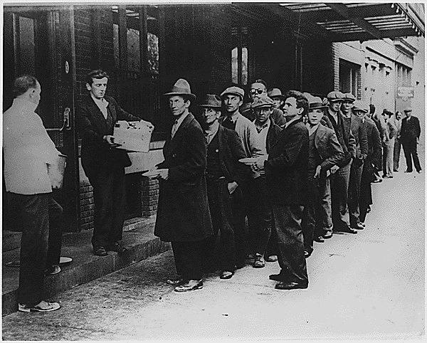
B

Depression Breadline in New York City (Circa February 1932)

Source 3

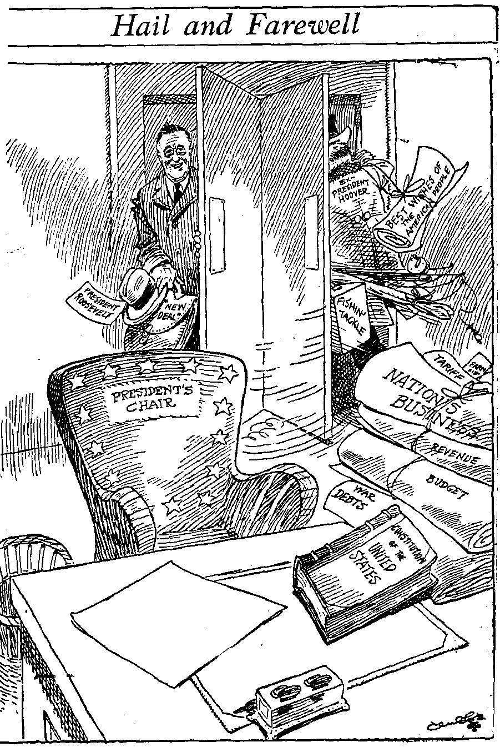
“Hail and Farewell”

This cartoon appeared in the Rochester (NY) Times Union
sometime between January 1933 and March 1933

Source 4

March 13, 1933

Dear Mr. President:

Your talk, last night, over the air, on our Banking Problems, was most inspiring. . . .

Most people, have very little money, and saving, a little for that "Rainy Day," is continual pinching, planning, scraping, and self-denial. And then it does not amount to very much. But at least, one has the feeling that in case of sickness, or unemployment, there is something in the Bank, to help out during a bad time. Then, out of a clear sky, one awakes to find oneself, out of work, and the bank holding the small savings, closed. And though worry does not help at all, one cannot do anything else but worry.

But you, Mr. President have instilled a new Courage, into the hearts of the American People. Even though, I have not worked for almost a year, and my savings are tied up, in a closed bank, I, and millions of others like me, feel, that at last, we can hope for the lifting of that terrible depression, that had almost broken the spirit of a good many of us. To tell you that we are thankful to you, for the new lease on life that you have given us, would not describe how we feel. So instead we'll pray that God speed you in your good work.

With all Good Wishes for your success, I am,

Gratefully yours

Jane Covant
Fair Haven, N.J.

Source: A letter to Roosevelt following one of his early “Fireside Chats”

Source 5

To the Congress:

It is essential to our recovery program that measures immediately be enacted aimed at unemployment- relief. A direct attack in this problem suggests three types of legislation. The first is the enrollment of workers now by the Federal Government for such public employment as can be quickly started and will not interfere with the demand for or the proper standards of normal employment. The second is grants to States for relief work. The third extends to a broad public works labor-creating program. With reference to the latter I am now studying the many projects suggested and the financial questions involved. I shall make recommendations to the Congress presently…

The first of these measures which I have enumerated, however, can and should be immediately enacted. I propose to create a civilian conservation corps to be used in simple work not interfering with normal employment, and confining itself to forestry, the prevention of soil erosion, flood control and similar projects. I call your attention to the fact that this type of work is of definite, practical value, not only through the prevention of great present financial loss, but also as a means of creating future national wealth…

More important, however, than the material gains will be the moral and spiritual value of such work. The overwhelming majority of unemployed Americans, who are now walking the streets and receiving private or public relief, would infinitely prefer to work…It is not a panacea for all the unemployment but it is an essential step in this emergency. I ask its adoption.

“Three Essentials for Unemployment Relief”- Roosevelt’s Address to Congress, 21 March, 1933.

Source 6

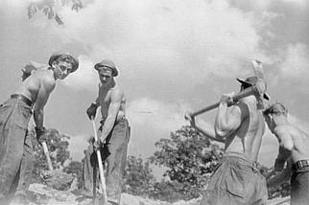

Typical Civilian Conservation Workers during the 1930’s

Source 7

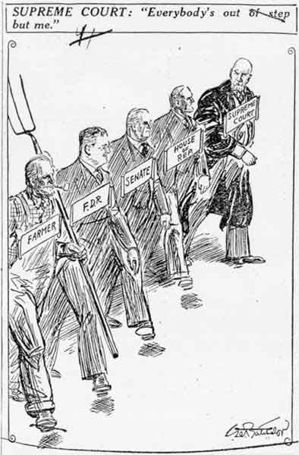

January 9, 1936, New York News, "Supreme Court: "Everyone's out of step but me.""

Source 8

Source: Del Marco, N. and Radway, R., (1997). The Twentieth Century: A World Transformed. Hodder and Stoughton: London.

Source 9

Many of Roosevelt’s experiments were failures, but that is what experimentation entails. He would be satisfied he said if seventy-five per cent of them produced beneficial results. Experimentation depended on one of his distinctive characteristics: receptivity to new and untried methods and ideas.

Written by American historian Samuel Rosemann.

